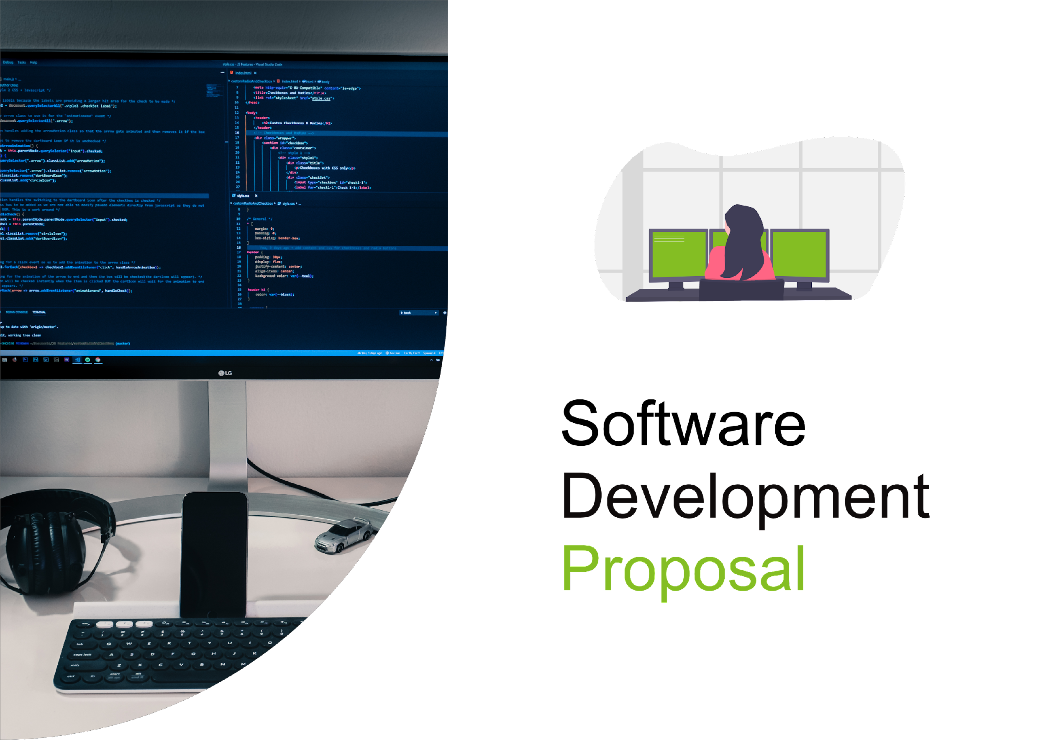

1. Overview

Daikibo is a company that operates four factories, and they collect telemetry data from nine machines in each factory. To monitor the health status of these machines, a private dashboard has been created which is accessible only within the client's intranet. The dashboard is designed to provide a quick overview of the current status of all monitored devices on a single page. Additionally, the view is collapsible/expandable at a factory level, as well as device level to show the history of statuses.

In summary, the private dashboard created for Daikibo's factories provides a secure and efficient way to monitor the health status of their machines. With the ability to authenticate users through an internal authentication server, the dashboard ensures that only authorized personnel can access the data. The dashboard's collapsible and expandable views also allow for a more detailed analysis of the data, enabling users to quickly identify issues and take corrective action.

2. Scope

The project includes the following features:

* Private dashboard with the health status of the 9 machines in each of Daikibo's 4 factories, for which they collect telemetry.
* Access to the page happens only within the client's Intranet.
* Authentication is synced to an internal authentication server (users can leverage their company-wide accounts).
* The dashboard consists of a single page, listing the current statuses of all monitored devices.
* The view is collapsible/expandable at a factory level and device level (showing the history of statuses).

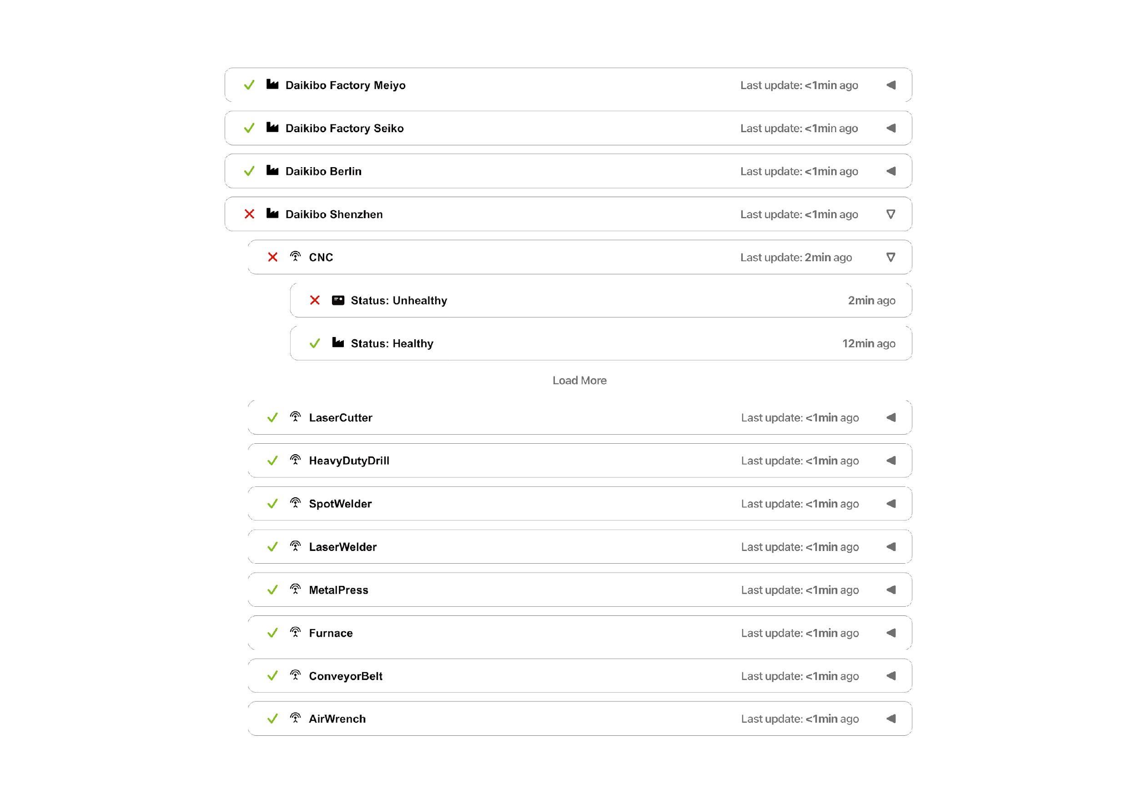

3. Estimate

[*An estimate of the total number of man-hours needed to get this project done + a breakdown of those hours into Development, Testing, and Integration of the product in the client’s Intranet*]

Development: Estimated 200 hours

Testing: Approx. 70 hours

Integration: Approx. 140 hours

Misc & Error handling: 50 hours+

**TOTAL**(in approx.): Around **500 hours**

Note: The above calculations have been done considering a team of 2-5 developers working on the project full-time along with a software tester and a back-end database engineer.

4. Timeline

1. [1st of September 2021] **Design starts**
2. [6th of September 2021] Designing process is done
3. [8th of September 2021] After the design is finalized, the development process starts
4. [3rd of October 2021] Initial version of the build is ready to review and use
5. [12th of October 2021] Integration of back-end starts
6. [*18th of October 2021*] Testing begins
7. [1st November 2021] **Ready for deployment**

5. Support

Some examples of the support we can provide post-release include:

* **Maintenance and updates:** We will ensure that the system is maintained and updated regularly to address any security vulnerabilities or issues that may arise. This can include installing updates, patches, and bug fixes.
* **Technical support:** We will provide technical support to troubleshoot any issues or bugs that may arise with the system. Our team will work with you to identify the root cause of the issue and provide a resolution as quickly as possible.
* **User support:** We can provide support to end-users of the system, helping them to navigate the system and troubleshoot any issues they may encounter. This can include providing training and user guides. Performance monitoring: We can monitor the performance of the system to identify any potential bottlenecks or issues that may impact the user experience. This can help ensure that the system is running smoothly and efficiently.

Overall, our goal is to provide comprehensive post-release support to ensure that the system remains reliable, secure, and functional over time. We are committed to providing the highest level of customer service and support to help you get the most out of your investment in the dashboard system.